RAJIV GANDHI COLLEGE OF ENGINEERING AND TECHNOLOGY
DEPARTMENT OF MECHANICAL ENGINEERING
T105 - ENGINEERING THERMODYNAMICS
UNIT IV – GAS POWER CYCLES

UNIT IV –Air standard cycles: The air standard Carnot cycle – Air standard Otto cycle, Diesel cycle, Dual cycle and Brayton cycles and their efficiencies

Part - A

- Define Thermodynamic cycle.
Thermodynamic cycle is defined as the series of processes performed on the system, so that the system attains its original state.
- What is meant by air standard cycle? (Nov 2011, April 2010)
If we use air as working substances in the thermodynamic cycles, it is called air standard cycle.
- Define Air standard efficiency.
Air standard efficiency is defined as the ratio of network transfer during the cycle to the net heat transfer to the cycle
- What are the assumptions made for air standard cycle analysis? (Nov 2011, May 2016)
- The working medium is prefect gas throughout i.e. it follows PV=mRT
- The working medium has constant specific heats
- The working medium does not undergo any chemical change throughout the cycle
- The compression and expansion processes are reversible adiabatic i.e. there is no loss or gain in
entropy.
- Kinetic and potential energies of the working fluid are neglected
- The operation of the engine is frictionless
- Heat is supplied and rejected in a reversible manner.
- For the same compression ratio and heat supplied, state the decreasing air standard efficiency of Otto, Diesel and Dual cycles.
Otto cycle efficiency > Dual cycles efficiency >. Diesel cycle efficiency
- Define Compression ratio. (April 2010)
Compression ratio is defined as the ratio between total cylinder volumes to clearance volume. It is denoted by ‘r’.
Total cylinder volume
R=
Clearance volume

- Define Cut off ratio.
Cut off ratio is defined as the ratio of volume after the heat addition to the before the heat addition.
Cut off volume
Cut off ratio =
Clearance volume

- Define Expansion ratio.
Expansion ratio is the ratio of volume of after the expansion to the volume of before expansion.
Volume of after the expansion
Expansion ratio =
Volume of before expansion

- Define the following terms in the Air Standard cycle, (i). Specific work transfer, (ii). Specific air consumption and (iii). Work ratio.
Specific work:
Specific work transfer is the work transfer per unit mass of working substance
Specific air consumption:
Specific air consumption is the quantity of working substance required for doing work transfer or the flow ratio of working substance for unit power.
- Define work ratio.
Work ratio is defined as the ratio of net work output to the work done by the turbine.
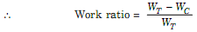

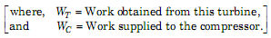

- Name the various gas power cycles
- Carnot cycle
- Otto cycle
- Diesel cycle
- Brayton cycle
- Duel combustion cycle
- Atkinson cycle
- Stirling cycle.

- Mention the various processes in diesel cycle.
- Isentropic compression
- Constant pressure heat addition.
- Isentropic expansion,
- Constant volume heat rejection
- Write any four differences between Otto and Diesel cycle? (Jan 2011)
Sl.No | Otto Cycle | Diesel Cycle
1 | Otto cycle consist of Two isentropic and two constant volume processes | Diesel cycle consist of two adiabatic, one constant volume and one constant pressure processes
2 | Heat addition takes place in constant volume process | Heat addition takes place in constant pressure process
3 | Efficiency is more than diesel cycle for the same compression ratio | Efficiency is less than Otto cycle for the same compression ratio
4 | Compression ratio is equal to expansion ratio | Compression ratio is greater than expansion ratio

- What are the processes involved in Dual cycle
- Adiabatic compression
- Constant volume heat addition
- Constant pressure heat addition
- Adiabatic expansion
- Constant volume heat rejection

- Compare the Diesel and Brayton cycles

Sl.no | Diesel cycle | Brayton cycle
1 | It consist of two isentropic, one  constant volume and one constant pressure process | It consist of two isentropic, one constant pressure processes
2 | Heat is rejected at constant volume | Heat is rejected at constant pressure
3 | Used in Diesel engines | Used in gas turbines

- Sketch Otto cycle on P-V and T-S diagrams, name all the process and write the expression for efficiency. (Jan 2010, May 2012, Jan 2015)
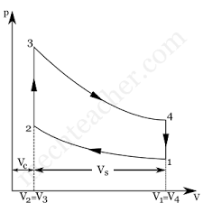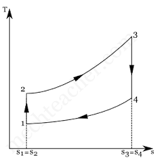

P-V and T-S diagrams of Ideal Otto cycle

Process 1-2 = Adiabatic compression
Process 2-3 = Constant volume heat addition
Process 3-4 = Adiabatic expansion,
Process 4-1 = Constant volume heat rejection
Efficiency of Otto cycle (η) = 1-1/(r) ^{γ-1}

- Why Brayton cycle is used in gas turbine?
Inside the turbine the gas is continuously flowing in the processes are flow processes. Since all the processes involved in Brayton cycle is flow process, it has been used as the cycle for gas turbine.

- Sketch Diesel cycle on P-V and T-S diagrams, name all the process and write the expression for efficiency. (May 2011)

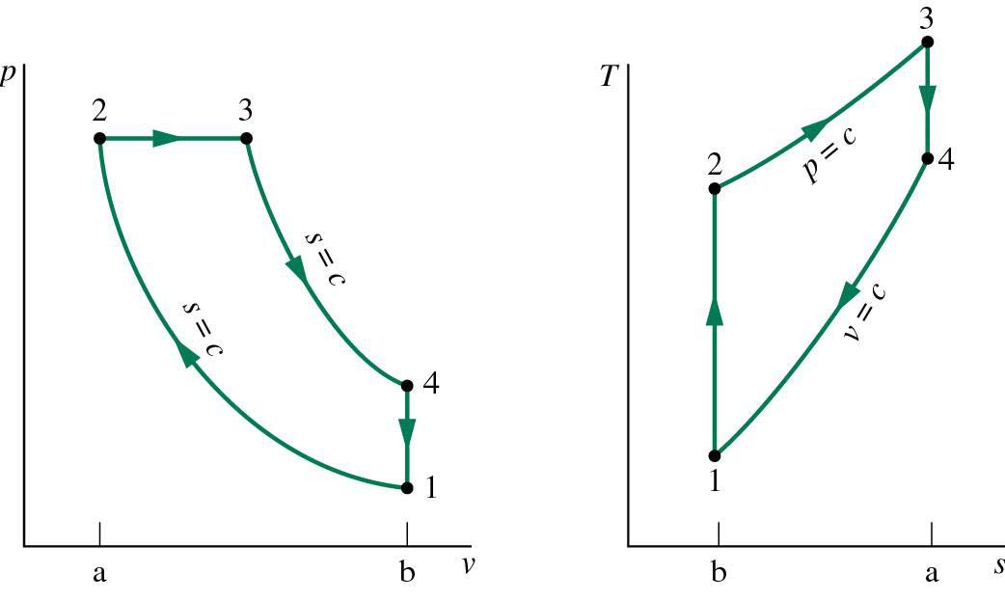
P-V and T-S diagrams of Diesel cycle

Process 1-2 = Adiabatic compression
Process 2-3 = Constant pressure heat addition
Process 3-4 = Adiabatic expansion
Process 4-1 = Constant volume heat rejection
Efficiency of Diesel cycle (η) = 1-1/ γ(r) ^{γ-1} = 1-1/ γ(r) ^{γ-1} (ρ^{γ}-1/ρ-1)

- What are the effects of evaporative pressure or suction pressure?

- The evaporative pressure or suction pressure decreases due to frictional resistance of flow of the refrigerant.
- The COP of system is ratio of refrigerating effect to the work done, therefore with the decrease in evaporative pressure, the net effect is to decrease the COP of the refrigerating system for the same amount of refrigerant flow.

- What are the effects of condenser pressure or discharge pressure? (Jan 2011)

- The condenser pressure or discharge pressure increases due to frictional resistance of flow of the refrigerant.
- The COP of system is ratio of refrigerating effect to the work done, therefore with the increase in condenser pressure, the net effect is to decrease the COP of the refrigerating system for the same amount of refrigerant flow.

- Sketch Dual cycle (or) pressure limited cycle on P-V and T-S diagrams, name all the process and write the expression for efficiency. (May 2012, Jan 2015)

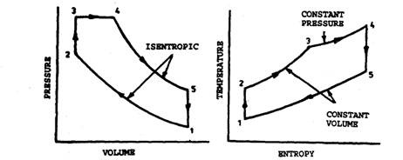
P-V and T-S diagrams of Dual cycle
Process 1-2 = Adiabatic compression
Process 2-3 = Constant volume heat addition
Process 3-4 = Constant pressure heat addition
Process 4-5 = Adiabatic expansion
Process 5-1 = Constant volume heat rejection

- What is meant by mean effective pressure? (May 2011)
Mean effective pressure is defined as the constant pressure acting on the piston during the working stroke. It is also defined as the ratio of work done to the stroke volume of piston displacement volume.
Work done
Mean effective pressure =
Stroke (or) swept volume.

- Why Carnot cycle cannot be realizes in practice?
- In a Carnot cycle, all the four processes are reversible but in actual practice there is no process is reversible.
- It is not possible to avoid friction between moving parts completely.

- Sketch Brayton cycle (or) Joule’s cycle on P-V and T-S diagrams, name all the process and write the expression for efficiency. (Jan 2011, May 2011, May 2015)
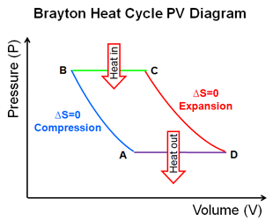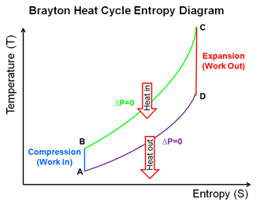
Process 1-2 = Adiabatic compression
Process 2-3 = Constant pressure heat addition
Process 3-4 = Adiabatic expansion
Process 4-1 = Constant pressure heat expansion.
Efficiency of Brayton cycle (η) = 1-1/(r) ^{γ-1} (In terms of compression ratio)
Efficiency of Brayton cycle (η) = 1-1 / (R_{p}) ^{γ-1} (In terms of pressure ratio)

- Differentiate between theoretical and actual P-V diagram. (Apr 2010)
Si.no | Theoretical P-V diagram | Actual P-V diagram
1. | The Maximum pressure is twice than that of an actual cycle. | The Maximum pressure is half of the theoretical cycle.
2. | The corners of the theoretical P-V diagram are sharp. | The corners of the actual P-V diagrams are rounded.
3. | Exhaust takes place at atmospheric pressure. | Pressure during exhaust takes stroke is above atmospheric pressure.
4. | The pressure during suction stroke is atmospheric pressure. | The pressure during suction stroke is less than atmospheric pressure.

- Sketch Carnot cycle on P-V and T-S diagrams, name all the process and write the expression for efficiency.
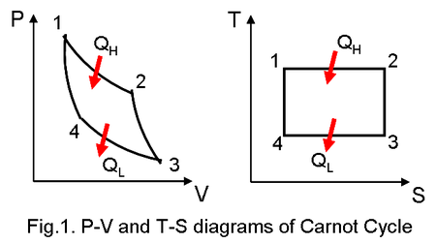
Process 1-2 = Adiabatic compression
Process 2-3 = Isothermal heat addition
Process 3-4 = Adiabatic expansion
Process 4-1 = Isothermal pressure heat expansion.

- Define isentropic efficiency of turbine and compressor in a Joule cycle.
It is defined as the ratio actual work to work adiabatic expansion.
η _{turbine} = Actual internal work / Work of isentropic expansion
It is defined as the ratio adiabatic compression to actual work.
η _{compressor} = Work of isentropic compression / Actual internal work

- What are the effects of introducing regenerator in the basic gas turbine cycle?
- The fuel economy is improved. The quality of fuel required per unit mass of air is less
- The work output from turbine, the work required to the compressor will not change.
- Pressure drop will occur during regeneration
- It increased thermal efficiency when the turbine operates at low-pressure ratio.

- What is the effect of air standard efficiency of Diesel cycle with compression ratio and cut off ratio?
Efficiency increases with the increase in compression ratio and vice-versa. The efficiency decreases with the increase in cut off ratio and vice-versa.

- What is the comparison of Otto, Diesel and Dual cycle?
- Same compression ratio and heat supplied.
- Same maximum pressure and temperature.
- Constant maximum pressure and temperature.

